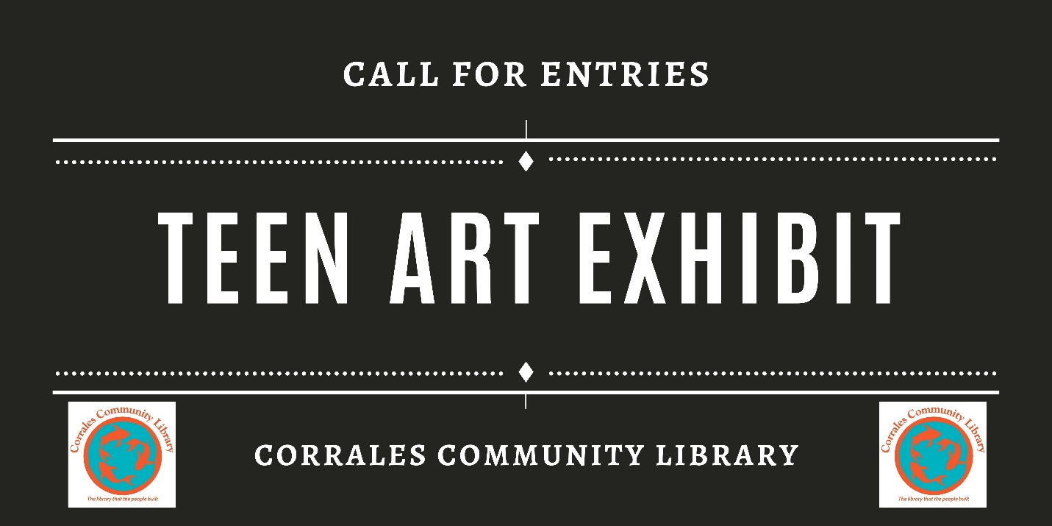
Corrales Teen Art Exhibit
Teen artists and art instructors, submit your or your student's portfolio to be featured at The Corrales Community Library! We are always on the lookout for original art exhibitions for the Library’s YA Room, and welcome submissions year-round.
If you are interested in exhibiting, submit your portfolio and printed application in person to the Library, or via the online Teen Art Application Form below. We accept portfolios submitted via CD, physical photographs, a website presentation, or Flickr gallery.
Exhibits are chosen by a staff committee according to the needs and interests of the community, the variety of the shows, the artistic quality of the works, and the suitability of format for the Library's YA Room. The average exhibit will be posted for 2-3 months, depending on the Library’s and artists' schedules. Read on to learn what you need to include in your exhibit submission.
PREFERRED PORTFOLIO SPECIFICATIONS
- Include 10 or 20 images that can be exhibited as a unit via photographs, CD, website presentation, or Flickr gallery. Photographs of work should be well-lit with the artwork placed in front of a neutral background.
- Each portfolio must include the artist's name, biography, current address, and phone number. They must also include information about each image, including medium, size, and direction of viewing.
- Each image submitted via CD, website presentation, or Flickr gallery must be an individual 300dpi JPEG file and cannot be larger than 1MB. Images must be in PC format. Website portfolios can be submitted as a URL on a letter of interest.
- Physical photographs must be submitted in a transparent plastic holder.
- Include a self-addressed, stamped envelope for the return of CDs or photographs
IF ARTWORK IS SELECTED
The City Library will:
- Install the exhibit
- If applicable, provide a reception night with light refreshments and snacks
- Produce postcard-sized show announcements
- Assume responsibility for damage or losses for an appraised value not to exceed $50 per piece while items are exhibited
- Submit press release and public service announcements to local media
- Include exhibit information on the Library's web calendar
The artist will:
- Provide fully framed, two-dimensional artwork wired from the back and ready for hanging
- Provide the Library with a biography and/or artist's statement
- Provide the Library with a list of titles and prices
- Provide artwork for the announcement postcard, if applicable
- Sign, together with a parent, legal guardian, or teacher, an exhibition agreement contract provided by the Library.

All artwork will remain on exhibit for the duration of the show. All sales inquiries are referred to the artist or their representative; the Library does not handle sales transactions.
For additional information, please contact Brynn Cole, Youth Service Librarian, at 505-897-0733 or at brynn@corraleslibrary.org

Teen Art Application:
Name

Address

Email

Phone

Website (Portfolio/Flickr Gallery)

Dates Available

If you are submitting a physical portfolio, check one of the following:
--I am submitting a self-addressed, stamped mailer for my portfolio to be returned.
--I do not want my portfolio returned.
--Please call me and I will pick up my portfolio

